MEDICATION [STATIN] CHOICE

Compared with patients without diabetes, patients with diabetes are at about twice the risk of having heart attacks and strokes.

What can you do on your own to decrease the risk of heart attacks and strokes?

        - Live an active lifestyle
        - Consume fish at least once a week
        - Prefer fruit, vegetables, and fiber.
        - Quit smoking
        - Drink alcohol with moderation
        - Maintain a lean body weight

As you might know by now not all people can complete these strategies. Even if you are able to do these successfully, there are medications that can help people with diabetes further reduce their risk of heart attacks and strokes.

This tool will help us determine whether a medication (a pill called statin), is or is not good for you.

Feel free to make notes throughout this tool.

Before we discuss the choices, there are other considerations to keep in mind.
What is a heart attack?
A heart attack is often called a myocardial infarction
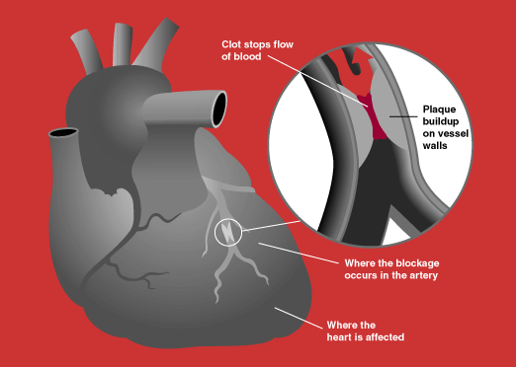
A heart attack occurs when the blood supply to part of the heart muscle is severely reduced or stopped. This may occur because of fat buildup inside the blood vessels that feeds the heart muscle, the coronary blood vessels. This buildup may break, causing the blood to clot blocking one of the vessels. If the blood supply is blocked for more than a few minutes, the heart muscle can suffer permanent damage. Depending on how much heart muscle is damaged, a heart attack can kill or disable a person.
Source: NIH

A heart attack can also kill a person when the heart attack causes a heart rhythm that stops blood pumping. People disabled by their heart attacks complain of shortness of breath with activity, fluid buildup, and tiredness (heart failure).

What happens when people with diabetes have heart attacks?
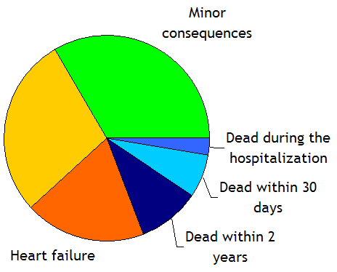
Other
Of 100 people with diabetes suffering a heart attack:
- 10 will die in the first 30 days after a heart attack and 10 more will die in the next 2 years
- 20 survivors will be left with some degree of heart failure
- 30 others will need to undergo some surgery (bypass surgery, angioplasty)
- 30 others will have other consequences (depression, impotence) or they will return to full health
Surgery

What is a stroke?

The same process of fat buildup and blood clots can also affect the blood supply to the brain and lead to a stroke. Clots coming up to the brain from the heart can also affect the blood supply to the brain (this can happen to people with a heart rhythm problem called atrial fibrillation).

Of 100 patients with diabetes who have strokes:
- 70 will have mild ones that leave little (e.g., numb feeling in an arm and leg) or no damage
- 30 will have larger strokes
  - 15 will be left with limitations, but will be able to return to previous activities
  - 15 will die or will have severe limitations that will not allow them to return to most previous activities (including activities such as eating and bathing without help or living independently)

Stroke survivors (including people who have suffered mini-strokes or TIAs) are at greatest risk of having another stroke.

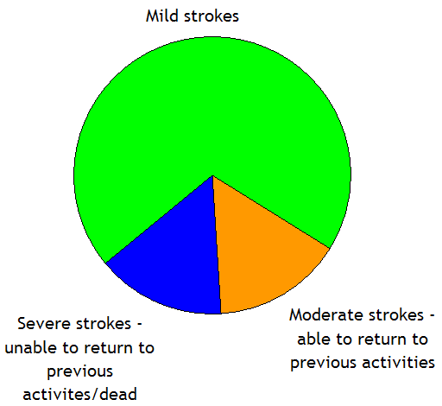
15
70
150
What are statins?

Statins are a class of pills that can prevent heart attacks and strokes in patients at high risk of having these conditions. They work by lowering the cholesterol (a type of fat) in the blood. Patients have been using statins for more than 15 years.

How do they lower cholesterol?
Statins block the production of a substance that is a building block needed to make cholesterol. This results is lowering of bad cholesterol (LDL).

How do they lower the risk of heart attacks and strokes?
Statins may help your body reabsorb cholesterol that has accumulated in fat buildup inside the blood vessels that feed the heart and the brain.

Statins may lower your risk of heart attacks and strokes by reducing or even preventing buildup in blood vessels and by other ways yet to be completely understood (by reducing inflammation).

What are available statins?
Lovastatin (Mevacor)
Pravastatin (Pravachol)
Simvastatin (Zocor)
Fluvastatin (Lescol)
Atorvastatin (Lipitor)
Rosuvastatin (Crestor)

All available statins can lower cholesterol. While some are more potent than others, all seem similar in their ability to help prevent heart attacks and strokes and deaths from heart attacks and strokes.

What is my risk of having a heart attack?

Nobody can tell for sure if you will or will not have a heart attack or a stroke.

In the STATIN CHOICE sheet we prepared with your information, you will find how we arrived at a best guess of what this risk would be for people like you.

We took into account:

- Your age, whether you are a man or woman, and for how long you have had diabetes
- Your smoking habit
- Your HbA1c (a marker of diabetes control)
- Your usual blood pressure
- Your cholesterol profile
- Your protein in the urine (a marker of problems with your blood vessels due to high blood pressure or diabetes)

We also considered whether you were taking other medications that people with diabetes may use that can also influence your risk for heart attacks and strokes.

Here is a list of potential medications we considered:
Available ACE inhibitors
Quinapril (Accupril)
Perindopril (Aceon)
Ramipril (Altace)
Captopril (Capoten)
Benazepril (Lotensin)
Trandolapril (Mavik)
Monopril (Fosinopril)
Lisinopril (Prinivil, Zestril)
Moexipril (Univasc)
Enalapril (Vasotec)

            - Metformin (Glucophage)
            - ACE inhibitors (see box)
            - Aspirin
            - Diuretics (water pills) for blood pressure control

 Now, review STEP 1 of your STATIN CHOICE sheet.

We did not take into account your family history or other information that may indicate to you or to your doctor that you are at lower or higher risk than what we estimated.

You can write in here those aspects we left out that you think are important in determining your risk of heart attacks and whether you think these aspects will make your risk higher or lower (as we did in the example below).

Because of this I think my risk is:
Aspects that would make me think that my risk would be different
Example
My father and brother had heart attacks before their 50th birthday | Higher | Lower | Not sure

Because of this I think my risk is:
Aspects that would make me think that my risk would be different
Higher | Lower | Not sure
Higher | Lower | Not sure
Higher | Lower | Not sure
Higher | Lower | Not sure
Higher | Lower | Not sure

If you were able to identify aspects that may change your risk of heart attacks, the information in your STATIN CHOICE sheet may no longer reflect the information you need to make a decision. Do not worry. You can still find out if statins are good for you with this booklet.

What benefits can I expect from taking statins compared to not taking statins?

We will now discuss the two options: we will present to you the benefits of taking medication as compared with not taking medication. We will also present the potential downsides of taking medications compared with not taking these medications.

Potential benefits if I take this medication (compared with not taking this medication)
- Statins can lower bad cholesterol (LDL cholesterol) and improve good cholesterol (HDL cholesterol).

- Statins can prevent heart attacks and strokes and deaths from heart attacks and strokes.

What is the goal of using statins?
Some experts suggest that statins should be taken to lower your bad cholesterol (LDL) to less than 100. Others suggest a goal of less than 70.

What is clear is that, when taken regularly, statins can lower the risk of heart attacks, strokes, and deaths from heart attacks and strokes regardless of the level of LDL cholesterol.

In other words, your risk of heart attacks and strokes may be more important than your cholesterol numbers in deciding whether you should or should not consider taking statins.

How effective are statins in lowering the risk of heart attacks?
High quality studies have consistently shown that statins can prevent about a quarter (25%) of the heart attacks and strokes and about 17% of the deaths due to heart attacks and strokes. What this means to people like you depends on your risk of having heart attacks without statins.

Remember that it is impossible for anyone to know for sure if you will benefit from taking statins.

 Now, review STEP 2 of your STATIN CHOICE sheet.
For people at risk of 15% or less of having a heart attack in the next 10 years:

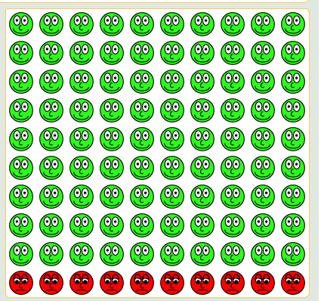
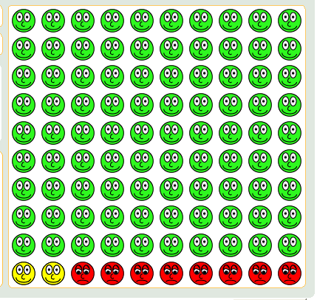
NO STATIN
Our guess of what will happen to 100 people like you if they were to decide to take statins: out of 100 people like you, about 8 will have a heart attack in the next 10 years, and about 92 will not.
About 2 people avoided a heart attack by taking statins; about 98 did not change their outcome by taking statins.
YES STATIN
Our guess of what will happen to 100 people like you if they were to decide NOT to take statins: out of 100 people like you, about 10 will have a heart attack in the next 10 years, and about 90 will not.
ATTENTION!
If you were to decide to take statins, we will not know if you would be among those who would not benefit (either by not having a heart attack or by having one despite taking statins regularly) or those who would benefit (by avoiding a heart attack by taking a statin).

 Had heart attack | Did not have heart attack | Avoided heart attack by taking statin
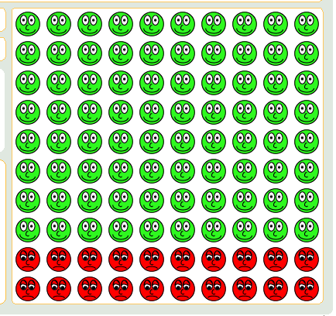
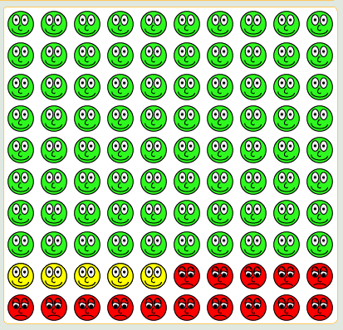
For people at risk of 15% to 30% of having a heart attack in the next 10 years:
NO STATIN
Our guess of what will happen to 100 people like you if they were to decide to take statins: out of 100 people like you, about 15 will have a heart attack in the next 10 years, and about 85 will not.
About 5 people avoided a heart attack by taking statins; about 95 did not change their outcome by taking statins.
YES STATIN
Our guess of what will happen to 100 people like you if they were to decide NOT to take statins: out of 100 people like you, about 20 will have a heart attack in the next 10 years, and about 80 will not.
ATTENTION!
If you were to decide to take statins, we will not know if you would be among those who would not benefit (either by not having a heart attack or by having one despite taking statins regularly) or those who would benefit (by avoiding a heart attack by taking a statin).
Had heart attack | Did not have heart attack | Avoided heart attack by taking statin
For people at more than 30% risk of having a heart attack in the next 10 years:

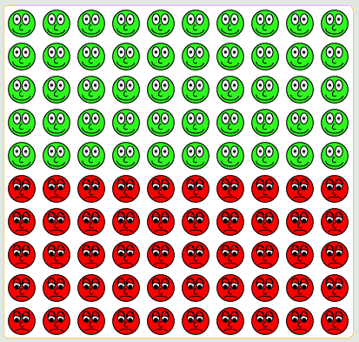
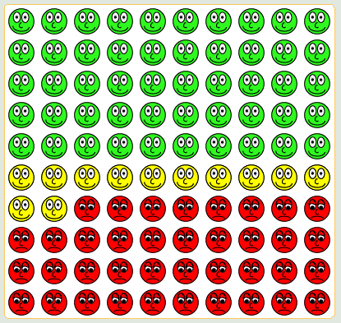
NO STATIN
Our guess of what will happen to 100 people like you if they were to decide to take statins: out of 100 people like you, about 38 will have a heart attack in the next 10 years, and about 62 will not.
About 12 people avoided a heart attack by taking statins; about 88 did not change their outcome by taking statins.
YES STATIN
Our guess of what will happen to 100 people like you if they were to decide NOT to take statins: out of 100 people like you, about 50 will have a heart attack in the next 10 years, and about 50 will not.
ATTENTION!
If you were to decide to take statins, we will not know if you would be among those who would not benefit (either by not having a heart attack or by having one despite taking statins regularly) or those who would benefit (by avoiding a heart attack by taking a statin).

Had heart attack | Did not have heart attack | Avoided heart attack by taking statin
What downsides can I expect from taking statins compared to not taking statins?

Potential downsides
Statins do not increase the risk of dying from cancer or other reasons.

Statins need to be taken every night for years.

Some statins will cost less than others to you depending on your drug plan.

Statins, like most other medications, have some common side effects (nausea, diarrhea, constipation) that most patients can tolerate without having to stop the medication.

Less common side effects:
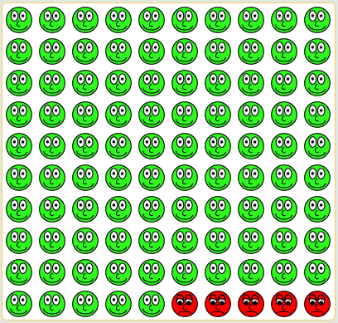
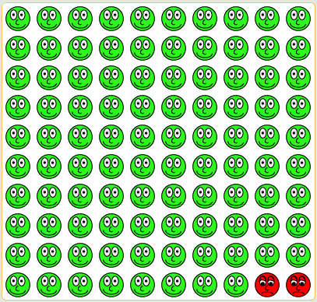
2 in 100
patients
In 1 in 20,000 patients statins may cause muscle damage; if the muscle breakdown becomes severe this may in turn damage the kidneys. These rare complications require stopping statins.
- Rosuvastatin (Crestor) appears more likely to cause these problems than other statins.
- Using statins with other drugs (like fibrates – Lopid, Tricor) may also increase the risk of this complication.

5 in 100
patients

Muscle aching/stiffness
Some patients may need to stop the medication for the symptoms to go away.
Feel fine but have test results that indicate that the statin is causing trouble in the liver. Stopping the medication almost always reverses the problem. It does not appear that statins cause severe permanent liver damage.

 Now, this information is also in STEP 3 of your STATIN CHOICE sheet.

Are there any other things you want us to discuss about using statins?

 Now, review STEP 4 of your STATIN CHOICE sheet.

You have reached the end of our guide.

IMPORTANT
This information reflects the current best available literature about statins in patients with diabetes. Our review of that literature is available upon request at advisory@e-bm.org.

Mayo Clinic staff that prepared this guide have not received funding or other support from makers of statin drugs. They prepared this guide without funding from the makers of statins.

