**FACILITIES & OTHER RESOURCES**

**Mayo Clinic Biobank**. The Mayo Clinic Biobank is an institutional resource for biological specimens, patient provided risk factor data and clinical data on patients recruited to the Biobank. The Biobank was funded by a Mayo Clinic initiative for Individualized Medicine to assist investigators throughout the institution in obtaining ‘normal’ samples to serve as controls for their patient populations. The consultative aspects of the resource aid investigators in determining whether these samples would serve as a methodologically sound source of controls for their studies, and assisting with various logistical aspects.

Preparations for the Biobank began in late 2007, with two weekend-long sessions with members of the local community in which we sought policy recommendations from them concerning collection and use of DNA samples. Community members continue to play an active role through our ongoing community advisory board. Recruitment is ongoing since April 2009. Participants come from volunteers and patients pre-scheduled for a medical examination in the Department of Medicine divisions of Community Internal Medicine, Family Medicine, General Internal Medicine, Obstetrics and Gynecology, or Preventive Medicine. All patients are age 18 years and older. Potential participants are invited via the U.S. mail. Non-responders are contacted via the telephone if no response within two weeks of invitation. Biological samples available on each patient include DNA, serum, plasma (including platelet-poor plasma) and an aliquot of frozen white blood cells. Data are available from the electronic medical record (medications, diagnoses, laboratory tests, administrative billing data) and from patient-provided information on current health, family health history, and various important factors known to confer risk for disease.

***Biobank Recruitment Procedures***

Biobank participants come from two sources. A few are unsolicited volunteers who heard of the Biobank and ask to participate. However, the majority of Biobank participants are randomly selected from Mayo Clinic Rochester, Mayo Clinic Florida, and Mayo Clinic Health System in La Crosse and Onalaska, Wisconsin patient appointments and invited to participate. This latter group is selected from among patients aged 18 years and older who are scheduled for a medical examination in the Department of Medicine divisions of Community Internal Medicine, Family Medicine, General Internal Medicine, Obstetrics and Gynecology, or Preventive Medicine. The potential participants are chosen with the use of a computer program that randomly selects subjects from potentially eligible patient appointments. Biobank materials, including a consent form, questionnaire and response form, are mailed to the home addresses of selected participants.

Interested persons are asked to read and sign the consent form, complete the questionnaire and return it via US mail. Invited persons who are not interested in participating are asked to check “refused” on the response form and return the form via US mail. If there is no response within 2 weeks of mailing, each subject is called on the telephone and reminded to return the response form.

***Biobank Recruitment To Date***

Recruitment for the Mayo Clinic Biobank began on April 1, 2009. To date, 143,463 persons have been invited to participate in the Mayo Clinic Biobank. 35,208 (24.9%) persons have consented to participate, 32,285 (22.5%) have consented to participate and have provided a blood sample and completed the questionnaire. Table X below provides information on the latter group by age and gender as of 11/11/2013.

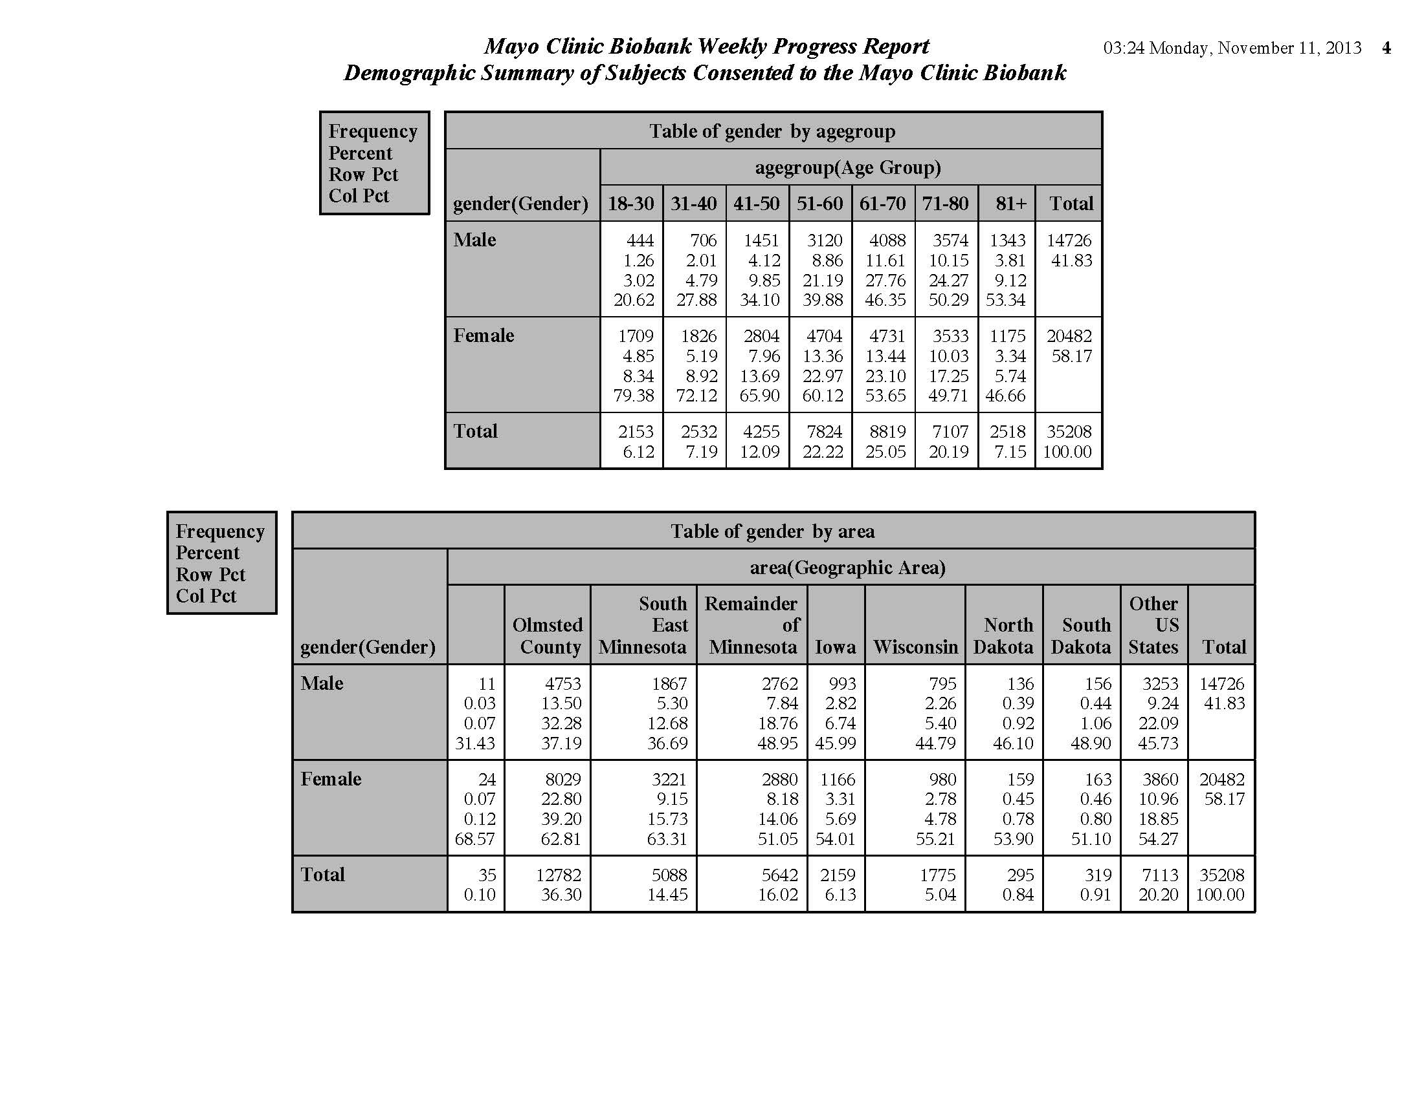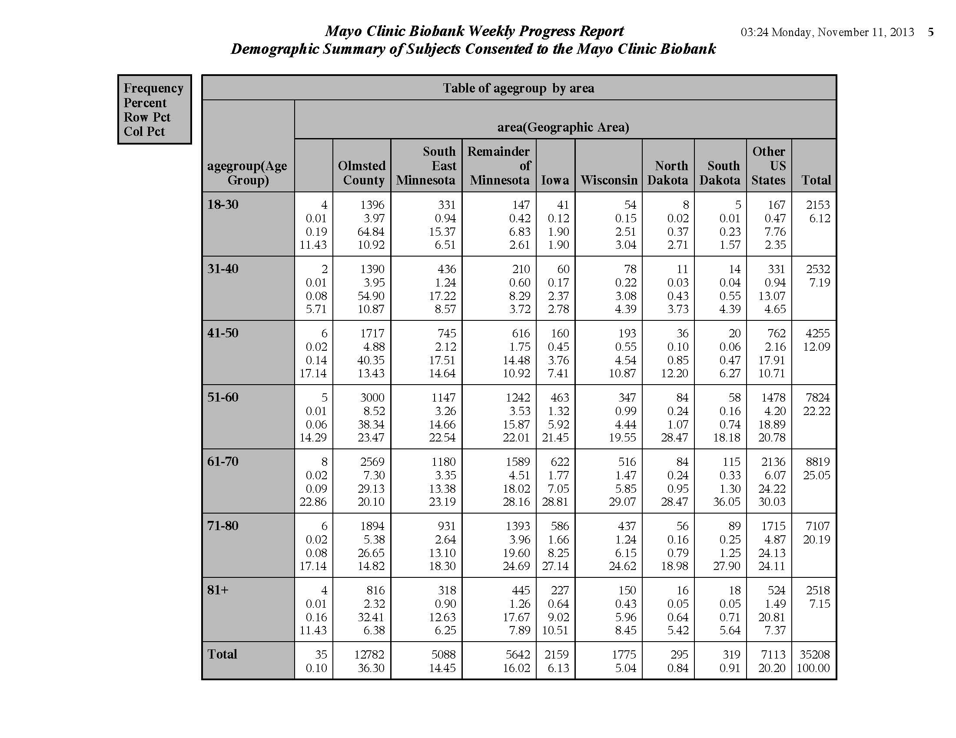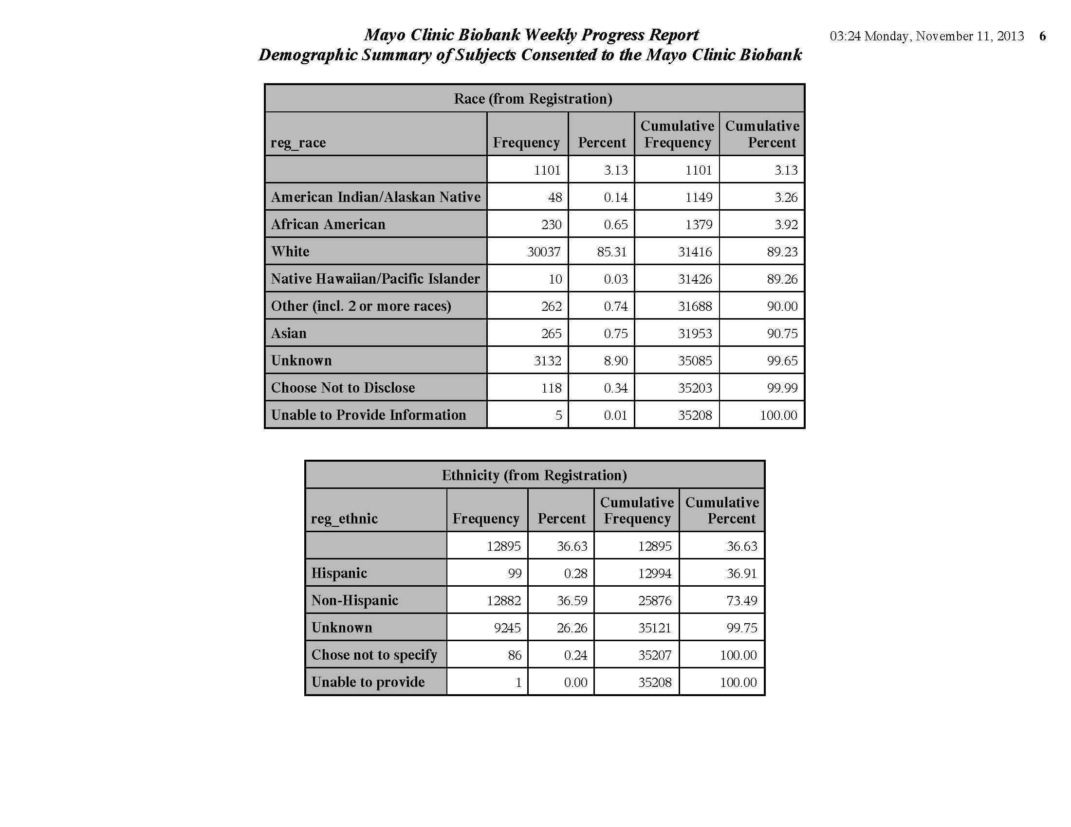

**Types of Specimens collected**

At this point in time, the following specimens are collected on each patient:

• 3* each of 10 ml EDTA tubes (for DNA, buffy coat, plasma. Note that some plasma samples are spun twice to obtain platelet-poor plasma

• 1 each of 10 ml no additive (For Serum)

• 1 each of 4.5 ml Sodium Citrate (for plasma)

*Note: on approximately 10% of patients, 1 -10 ml sodium heparin tube replaces one of the EDTA tubes. This Na Hep tube is collected, processed and slow-frozen so that the cells remain viable for future EBV transformation.

This yields the following specimens typically available on each patient:

* 860 μg of DNA (median)
* 3 aliquots of white blood cells (buffy coat)
* 4.5 mL EDTA plasma
* 4.5 mL platelet poor plasma
* 3.5 mL serum
* 2.0 mL Na Citrate plasma

***Use of Biobank Subjects as controls for “this” study***

Controls for this will be selected from the pool of Biobank participants so that they are frequency matched to the case distribution on 5-year age group, sex and area of residence.

*If you want to match on geography:*

Geographical region categories will consist of Olmsted County (the county in which Mayo Clinic is located), the counties surrounding Olmsted in southeastern Minnesota, the remainder of Minnesota, Wisconsin, and Iowa.

*Justification of Matching Technique*

We elected to use frequency matching over individual (exact) matching due to the inflexibility of the latter design for recruitment (added complexity and cost in control identification), and potential loss of power due to unmatched cases (Wacholder 1992c).

All exclusion criteria applied to cases (as described in section….) will be similarly applied to this control group. This control selection and recruitment strategy has been used successfully in several peer-reviewed NIH funded studies, including R01 CA86888 (Hartmann), R01 CA92153 (Cerhan), and P20 CA102701 (Petersen).