**Research Registration Application Quick Reference Guide**

The purpose of this guide is to find quick solutions for how to use the Research Registration Application. For questions regarding the use of the application or assistance with system issues, contact the Research Registration Office at [random01@mayo.edu](mailto:random01@mayo.edu).

Table of Contents

Gaining Access to the System 3

Complete Research Registration Application Training Module 3

Create a Professional Account 3

Log In to the Research Registration Application 4

Application Link 4

Home Page 5

Studies Tile: 5

Search for a specific study or patient: 5

Study Landing 6

Status Tile 6

Notifications Tile 6

Dosage Tile 6

Contact List Tile 6

Accruals Tile 6

Active List Tile 7

Patient Landing 8

Event List 8

Registration Tile 8

Patient Status Tile 8

Study Tile 9

Double Blind Tile 9

Register a Patient 10

Continue an In-Progress Registration 17

Multi-Step Registrations 20

Slot Reservation Studies 22

Create a Reservation 22

Manage Reservations 24

Study Reservations Preview Pane 25

View Reservation Summary 26

Registering a Patient with a Slot Reservation 27

# Gaining Access to the System

## Complete Research Registration Application Training Module

To ensure Code of Federal Regulation (CFR) 21 Part 11 compliance, all individuals who will access the Research Registration Application will need to complete role-specific training.

* **Mayo Clinic users** – Complete the training module, “Protocol Lifecycle Management (PLM): Research Registration Application” on My Learning. Once complete, training certification will be added to your account within one business day.
* **External users** – Complete the training located on the [Mayo Clinic Office of Clinical Trials, Site Management Team website](http://ctsa.mayo.edu/education/ctsa-courses/professional-development/PLM_ResearchRegistration/story.html). Once this training is complete, complete the [Attestation of Training](https://www.mayo.edu/research/documents/trainingattestation/doc-20477849) and send to the Research Registration Office at [random01@mayo.edu](mailto:random01@mayo.edu).

The training only needs to be completed one time for access to the Research Registration Application. Users will not be required to retake the module or send the Attestation of Training for each study.

## Create a Professional Account

External users will need to create a professional account to login to the Research Registration Application. Mayo Clinic staff will not need to complete this step.

1. Click “Create Your Account” link on the login page.

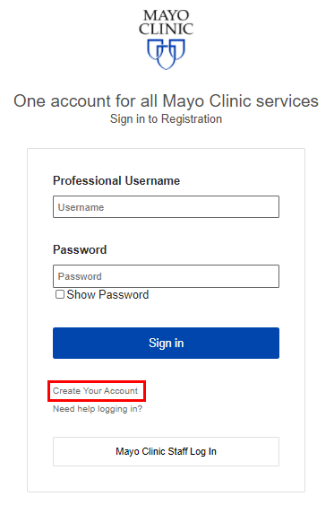

1. Complete all required fields.
2. Choose your username and password.
3. After submitting account information, users will receive an email to finish the account setup process.
   * The email will be sent from Mayo Clinic Online Services. Check spam/junk folder if email is not received.
4. Click the link within the email to verify email address and complete the account setup process.

For access assistance, contact the Research Registration Office at [random01@mayo.edu](mailto:random01@mayo.edu).

# Log In to the Research Registration Application

## Application Link

<https://registration.mayo.edu/home>

**Mayo Clinic Users**

* Click the link labeled “Mayo Clinic Staff Log In” in the box near the bottom of the screen.

**External Users**

* Enter the username and password selected when creating professional account.
  + If professional account has not been created, refer to instructions above.
  + If user forgot their username or password, click the “Need help logging in?” link on the login page.

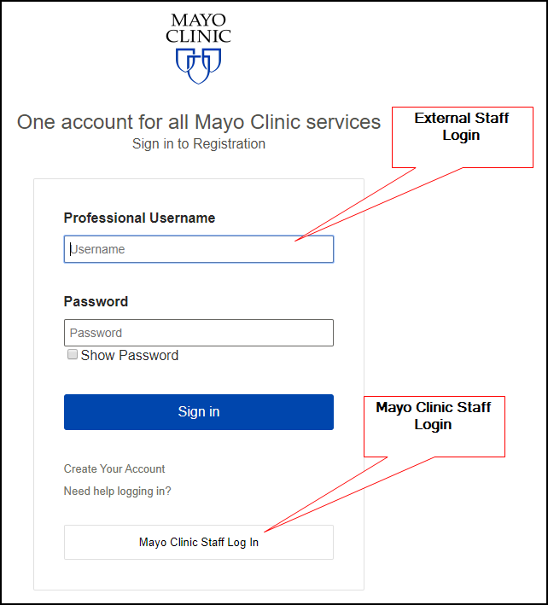

* Once logged in, the user will be directed to the Home Page of the application.

# Home Page

The home page features the Studies tile and the Study and Patient Search feature.

### Studies Tile:

* Displays the number of studies that the user is authorized to view.
* Clicking the “View Studies” button on the tile will display the list of accessible studies with links to access the Study Landing pages within the application.

Search for a specific study or patient:

1. Use the down arrow to select the Search by criteria.
   1. Studies can be searched by the sponsor protocol number or Mayo IRB number (if applicable) associated with the study.
   2. Patients can be searched using the Registration Application-generated subject ID. Partial queries are acceptable.

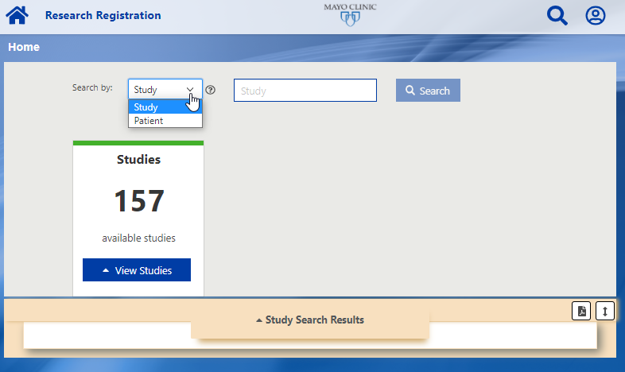

1. Results will be listed in the Search Results panel at the bottom of the screen.
2. Click the blue link (either study # or patient ID) to view the corresponding Study Landing Page or Patient Landing Page.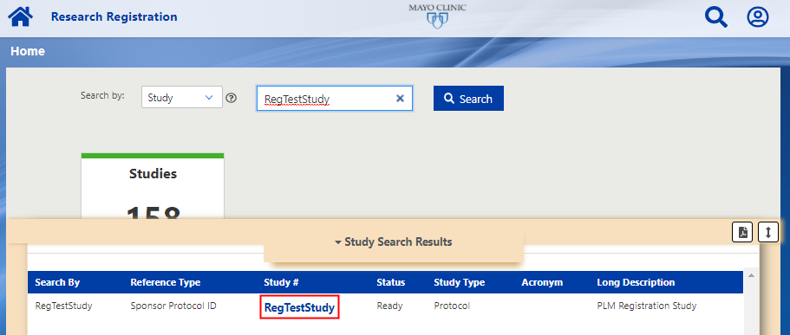

# Study Landing

Selecting a study reference ID will bring you to the corresponding Study Landing Page.

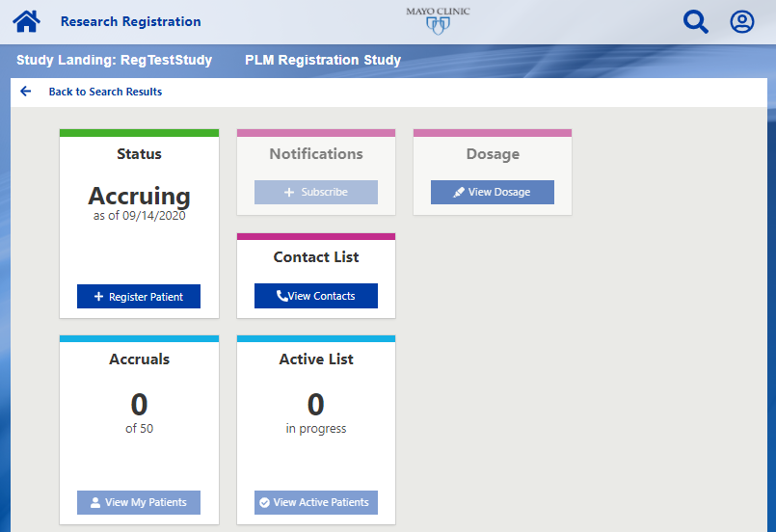

### Status Tile

* The Status tile provides the current study status: Accruing, Temporarily Closed, or Permanently Closed. The Register Patient button only functions if the status is listed as Accruing.
* The Register Patient button is used to initiate a patient registration on that trial. Clicking this button will bring the user to the registration screen.

### Notifications Tile

* Functionality is not currently available.

### Dosage Tile

* Available for studies that have dose level(s) configured (i.e. Phase I or Dose-Finding studies). Click the View Dosage button to view the current dose level for the study.
* If a study is not utilizing different dose levels then this tile will remain unavailable.

### Contact List Tile

* Provides list of sponsor-level study contacts. The contacts will display in the preview pane.
* Role, name, email address, and phone number are provided for each study contact.

### Accruals Tile

* Displays the total number of patients accrued to the study out of the projected accrual of the study.
* The View My Patients button will display a list of all patients that have been registered at the user’s authorized sites. To view more information for the patient, click the blue subject ID link to display the Patient Landing page.

### Active List Tile

* Displays the number of registrations the user has in-progress for the study.
* The View Active Patients button will display a list of all patient registrations that are currently in-progress. To continue the registration, click the blue subject ID link to display the Patient Landing page.

# Patient Landing

The Patient Landing page for a patient can be accessed via the search function on the Home page or by selecting a patient from the View my Patients list on the Accruals tile on the Study Landing page.

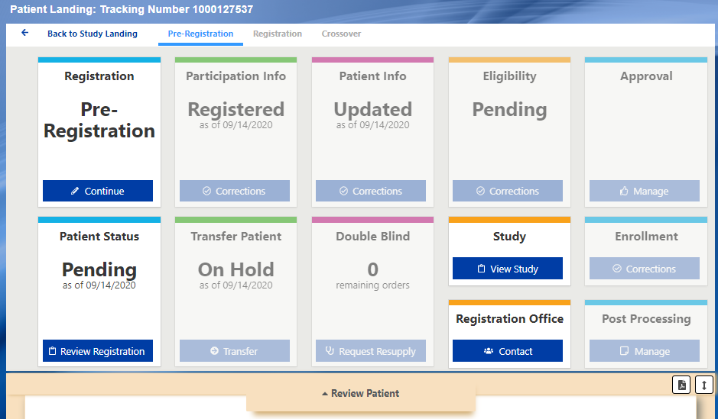

### Event List

* The study-specific registration events are found in the top menu.
* The event that is currently displayed will be light blue and underlined. Click an event link to view landing page for each event.
* Events that have not been started or completed for the patient are not accessible (text will be grey).

### Registration Tile

* Displays the current event for which a registration has been initiated for the patient. If there is a succeeding registration event, it will display the next available registration event title after the registration is completed.
* The Continue button is used to continue the registration at this event if it was saved in-progress or initiate the next registration event for the patient (if applicable). Clicking this button will bring the user to the corresponding registration page.

### Patient Status Tile

* Displays the status of the current registration event and the date the status was updated:
  + Pending indicates the registration is in-progress.
  + Registered indicates the registration is complete.
* The Review Registration button will display the current registration summary in the preview panel at the bottom of the screen.
  + IMPORTANT – this will display both in-progress and complete registration summaries. If the status is still “Pending” on this tile then the registration is not complete.
* When the registration is complete, you can save or print the registration confirmation by clicking the PDF icon on the preview pane.

### Study Tile

* The View Study button on the Study tile will navigate to the Study Landing page.

### Double Blind Tile

* For studies utilizing the double blind kit assignment functionality, this tile will display the number of orders remaining for a patient.
* Click the Request Resupply button to receive the next kit assignment for the patient.
* If there are zero kits remaining, the Request Resupply button will not function. If another kit is needed for a patient with zero kits remaining, contact the Site Management team at [ResearchSiteManagement@mayo.edu](mailto:ResearchSiteManagement@mayo.edu)
* All assigned kits will be displayed on the Review Registration summary generated on the Patient Status tile.

The following tile functionality is not being utilized.

* Participation Info Tile
* Patient Info Tile
* Approval Tile
* Transfer Patient Tile
* Enrollment Tile
* Registration Office Tile
* Post Processing Tile

# Register a Patient

1. Search for the protocol number using the Study search function on the Home Page or click the “View Studies” button on the Studies tile to display a list of your authorized studies.
2. Click the blue study link to access the Study Landing page.



1. On the Study Landing page, click the “Register Patient” button on the Status tile.
   1. The status must be Accruing and your site must be open to enrollment to initiate a patient registration. If you receive a message that registration is not available, contact the Registration Office at [random01@mayo.edu](mailto:random01@mayo.edu)

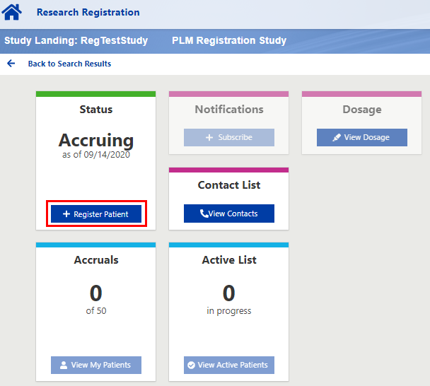

1. The Registration page will be displayed.
   1. If there is more than one registration step then it will display the registration page for the first registration step. The Event name will be displayed on the top menu.

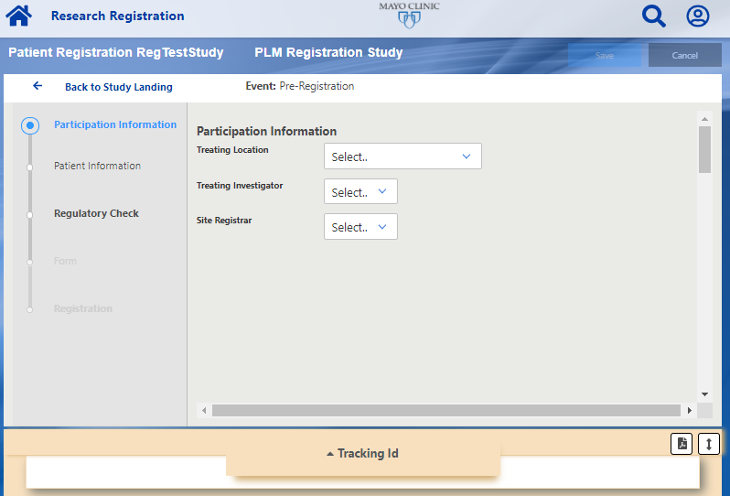

1. **Participation Information**: This section collects the location information, treating investigator, and any other applicable study roles that are required for the study.
   1. If applicable site or personnel is not available in the dropdown, contact the Research Registration Office ([random01@mayo.edu](mailto:random01@mayo.edu)) for assistance.
2. **Patient Information:** This section collects the patient’s demographics.
   1. Typical demographic information includes:
      * Patient Initials (Last, First, Middle (optional)
      * Gender
      * Race
      * Ethnicity
      * Date of Birth
      * Country
      * Method of Payment
      * MedDRA Disease Code
        + If unsure of the appropriate disease code, refer to the patient’s treating physician for guidance.
   2. Mayo Clinic only: Mayo Clinic Number   
      Enter the Mayo Clinic number and click “find” button. A pop-up window will indicate if a patient has been found in PTrax with the appropriate status (Enrolled). If the patient is not found or if not in the Enrolled status, the user will not be able to proceed with the registration until PTrax is updated.

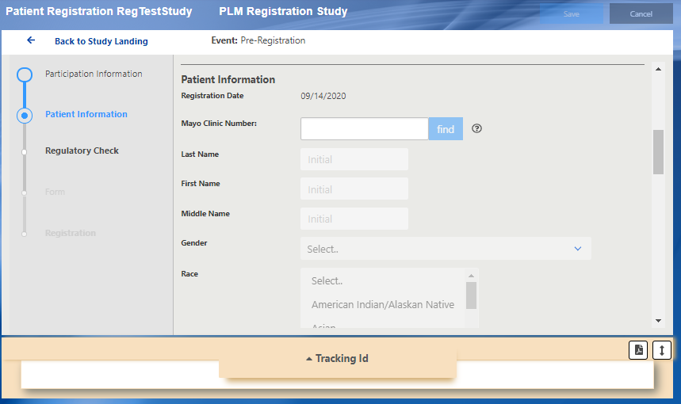

1. **Regulatory Check:** After the Participation Information and Patient Information have been entered, click the Regulatory Check button on the Validate tile. This will verify that the treating location and selected users are approved to participate on the study and confirm that all required demographic data has been entered.

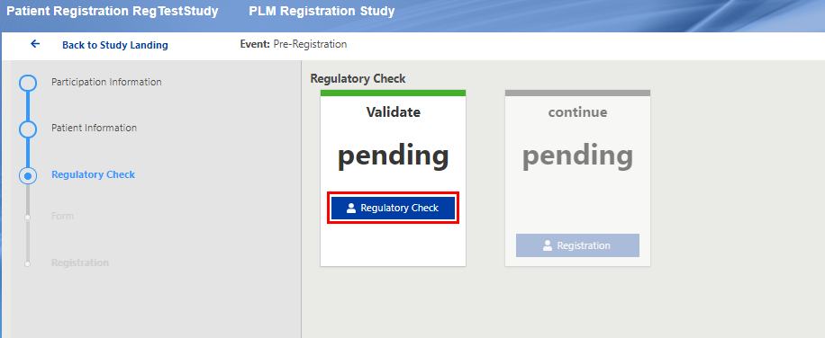

1. If no errors are found, the status will change to Complete and the Validate tile will display a Tracking ID for the patient. At this point, the registration is saved in progress so the user can either click the Registration button on the Continue tile to proceed with the registration or leave the application and return to finish it at a later time.
   1. If errors are found, contact the Research Registration Office at [random01@mayo.edu](mailto:random01@mayo.edu) for assistance.

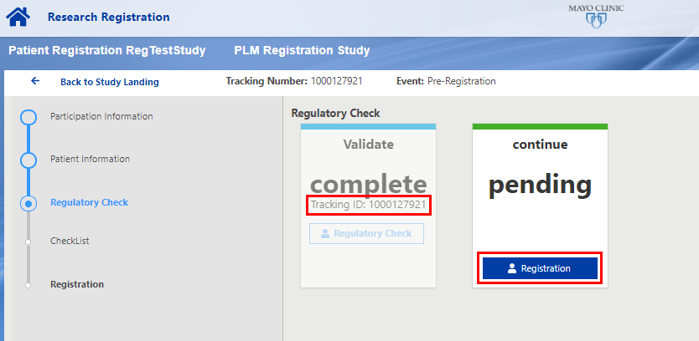

1. **Checklist:** To proceed with the registration, click the Registration button on the Continue tile. This will bring up a preview of the registration summary with the information previously entered in the Participation Information and Patient Information sections.

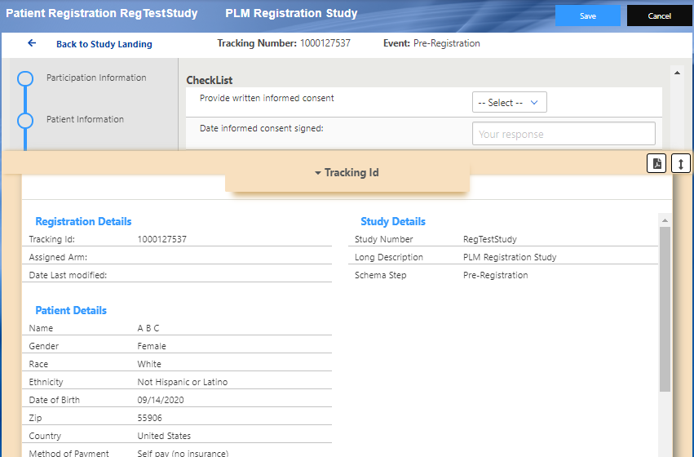

1. Minimize the preview pane by clicking on Tracking Id to proceed with the eligibility questions that are required at the time of patient registration.
   1. Questions can be answered using a dropdown, a date field, or free text, depending on the type of question. Dates can be typed manually or selected using the calendar function.

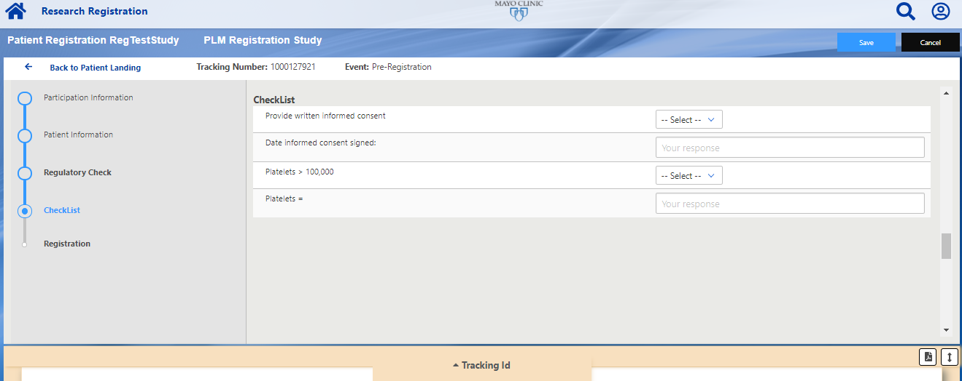

1. When you have completed all of the Checklist questions, scroll to the bottom of the screen and click the “Validate and Register” button. This will verify all of the questions on the checklist have been entered with valid answers.

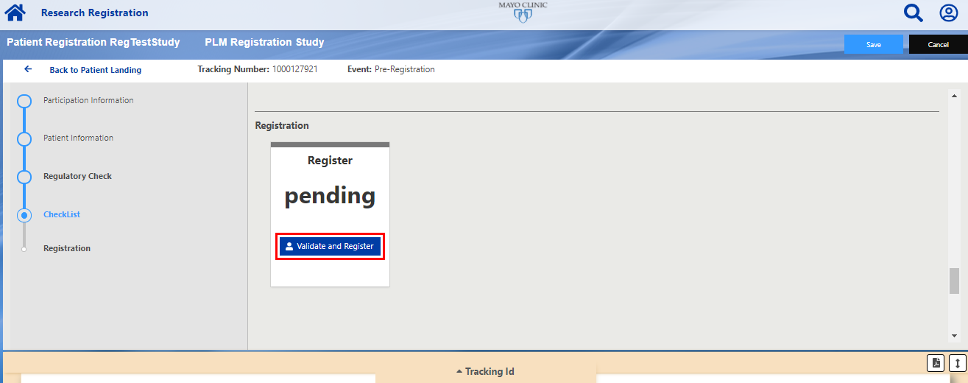

1. If any errors are found, the tile will display the number of errors found on the form. Click the Review Errors button to view the errors on the checklist and update the answers as needed.

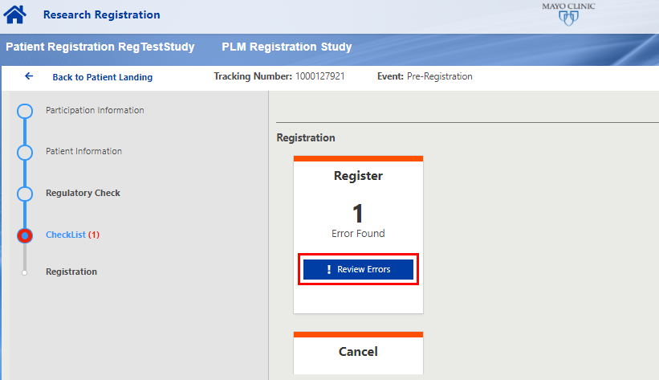

1. Any questions with errors will provide an error message explaining why the answer provided is invalid. If valid answers are not provided, the user will not be able to submit the registration.

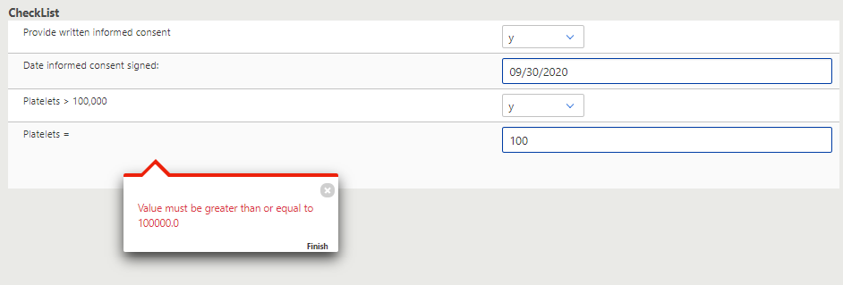

1. Scroll to the bottom of the screen to click the Validate and Register button again. If no errors are found, the tile will display the “complete” status and provide the assigned Patient ID. This indicates that the patient has been successfully registered to the study.

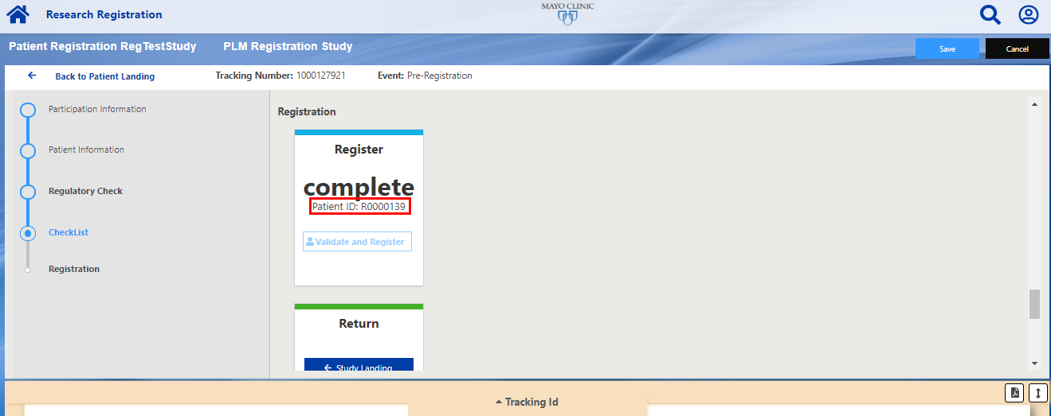

1. Click Tracking Id on the preview pane to view the registration confirmation. If applicable, this will display the patient’s Assigned Arm and Kit Assignment for double blind studies.
2. To save or print this confirmation, click the PDF icon to generate a PDF of the information provided.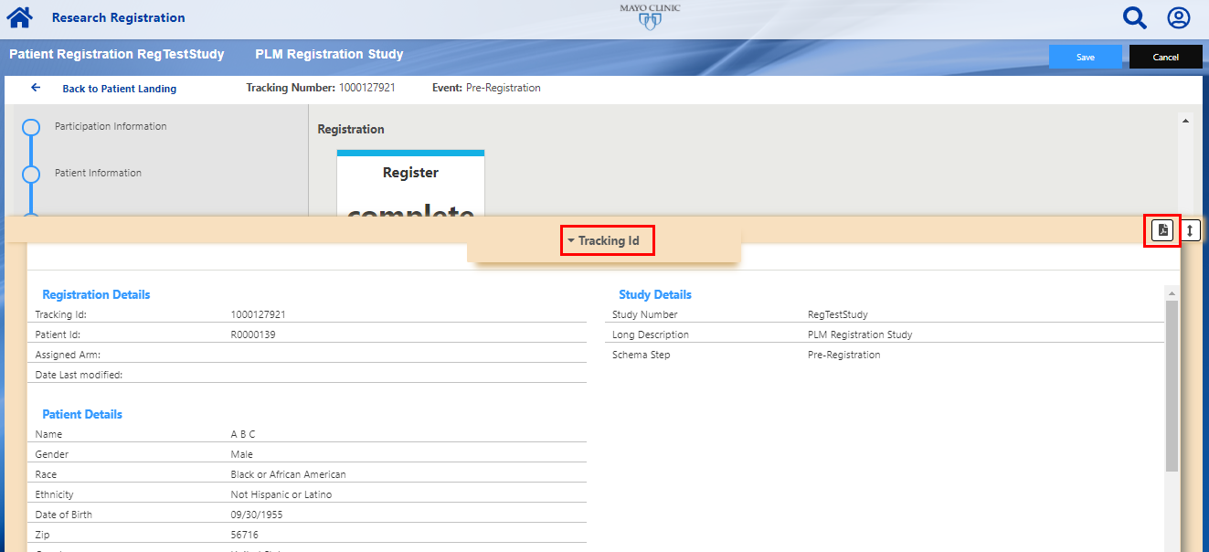
3. The registration confirmation PDF can also be accessed from the Patient Landing page after the patient is registered. Click on the Review Registration button to view the registration summary. There is a PDF icon on the preview pane to generate and save the PDF registration confirmation.

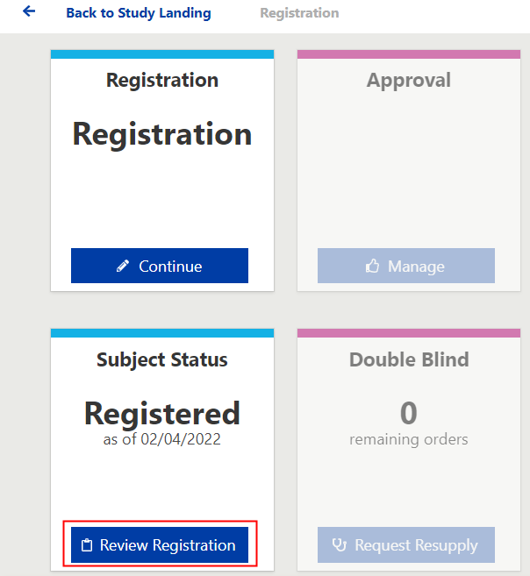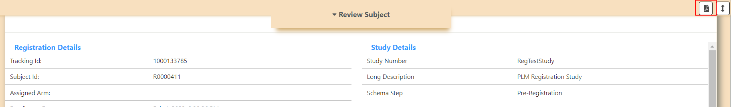

# Continue an In-Progress Registration

When a registration is saved in-progress, it will appear in the Active List which is accessible from the Study Landing page.

1. To proceed with an in-progress registration, click the “View Active Patients” button on the Active tile on the Study Landing page.

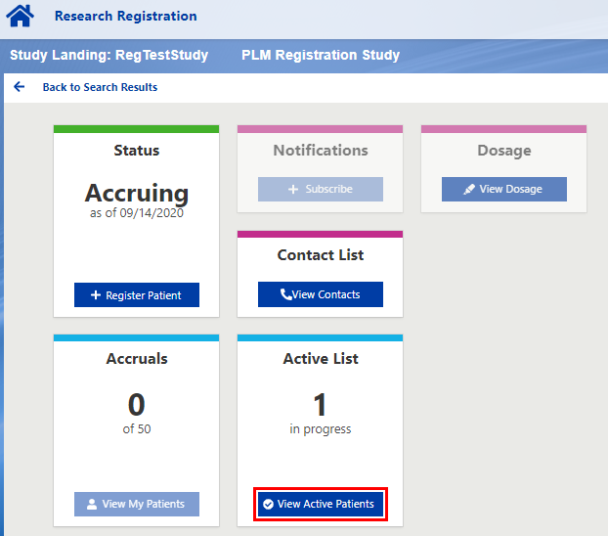

1. The Active Patients preview panel will display the list of in-progress registrations.
   1. It will display the assigned Tracking ID, patient initials, date of birth, enrollment event, and the data entry person for the registration. If the patient was preciously assigned a patient ID (i.e. on a previous enrollment event) then it will also display the patient ID.
2. Click the blue Tracking ID link to access the Patient Landing page.

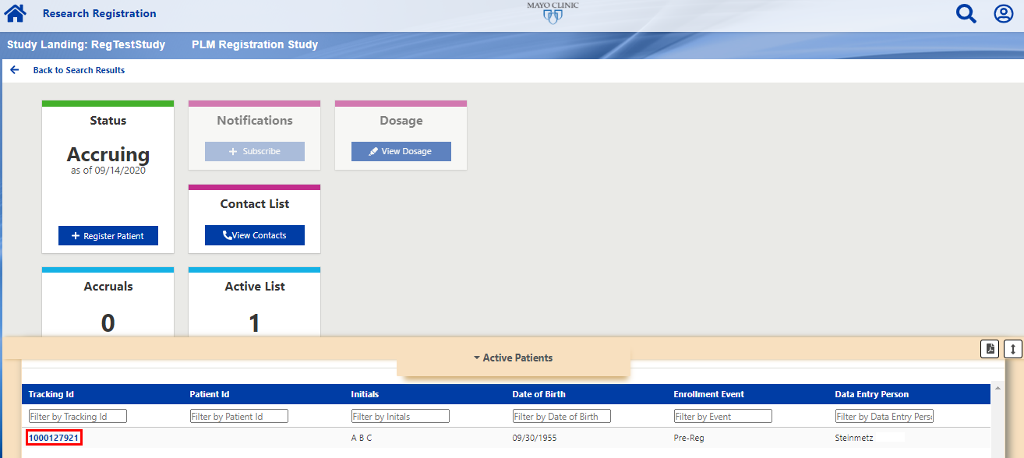

1. The Patient Landing page will be displayed. The Registration tile will display the current enrollment event for the patient. The Status tile will display the current status of the enrollment:
   1. Pending = registration is in progress for that step
   2. Complete = registration is complete for that step
2. To proceed with the registration, click the “Continue” button on the Registration tile. This will bring the user to the registration screen with the previously entered information for the patient.
   1. Note: The user will be required to click the “Regulatory Check” button again before accessing the checklist questions.

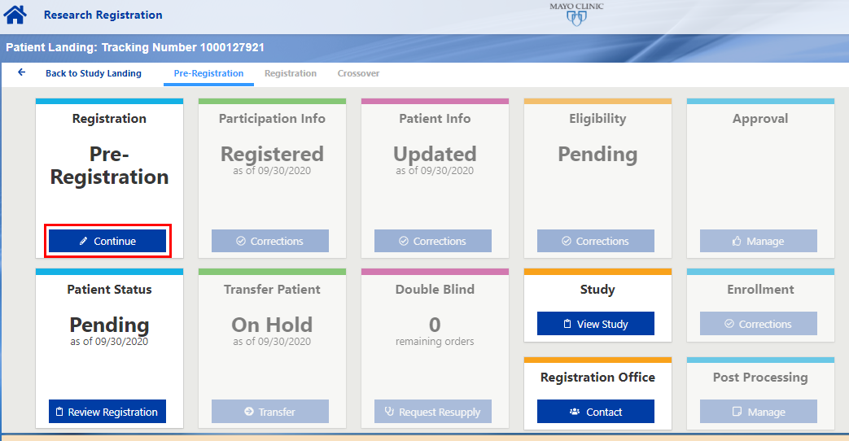

# Multi-Step Registrations

For studies that have more than one registration event, follow the procedure below to complete succeeding registration steps after the initial registration step is completed.

1. Find the patient in the Registration App using one of the following methods:
   1. Search for the patient ID in the patient search box on the Home Page
   2. Go to the Study Landing page and click the View My Patients button to view a list of patients registered to the study. If needed, filter the results to find the patient

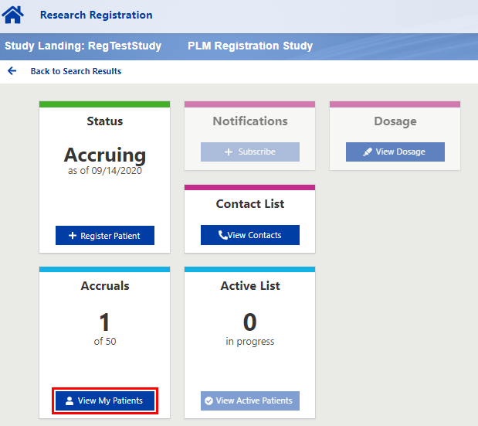

1. Click the blue patient ID link to view the Patient Landing page.

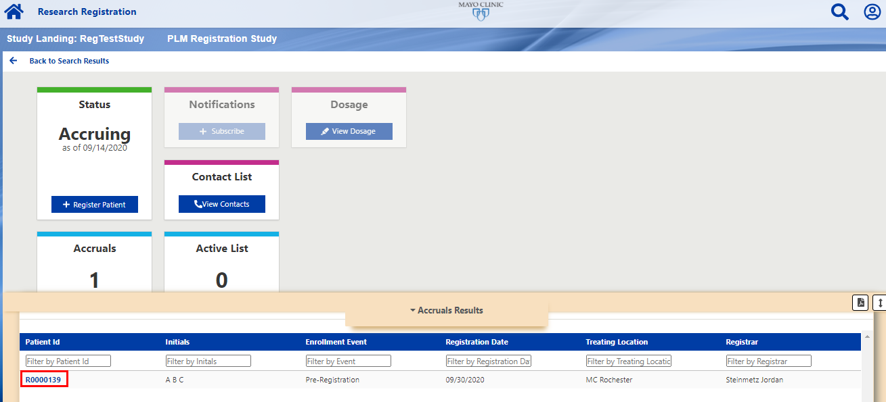

1. The Patient Landing page will display the most recent registration event that has been initiated or completed for the patient.
   1. The top menu will display all registration events for the study. The event that is currently displayed will be blue and underlined.
2. The Registration tile will display the name of the next available registration event. Click the Continue button to proceed with the next registration.

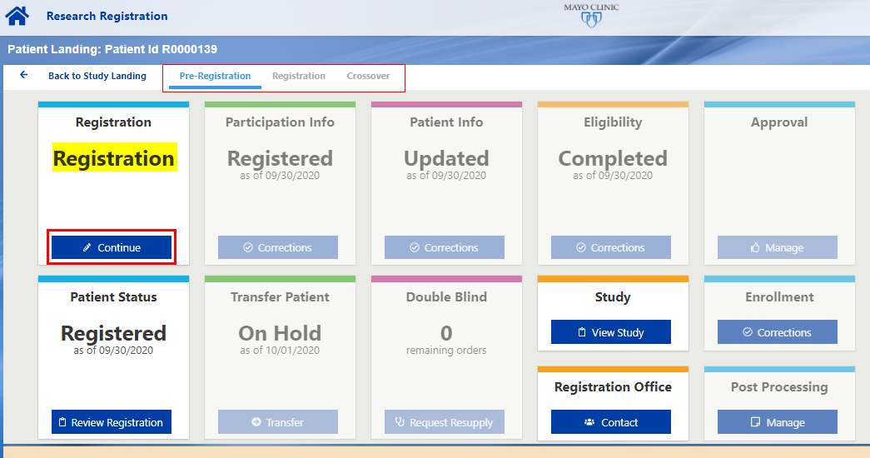

# Slot Reservation Studies

Refer to the Registration Procedures in the protocol to determine if a slot reservation is required prior to registration for a study. If slot reservation is required, follow the steps below to Create a Reservation, Manage a Reservation, and complete a registration with a Reservation.

## Create a Reservation

1. On the Study Landing Page, click the “Create Reservation” button on the Reservations tile.

Note: A pop-up message will display if there are no reservations currently available. Contact the Registration Office with any questions.

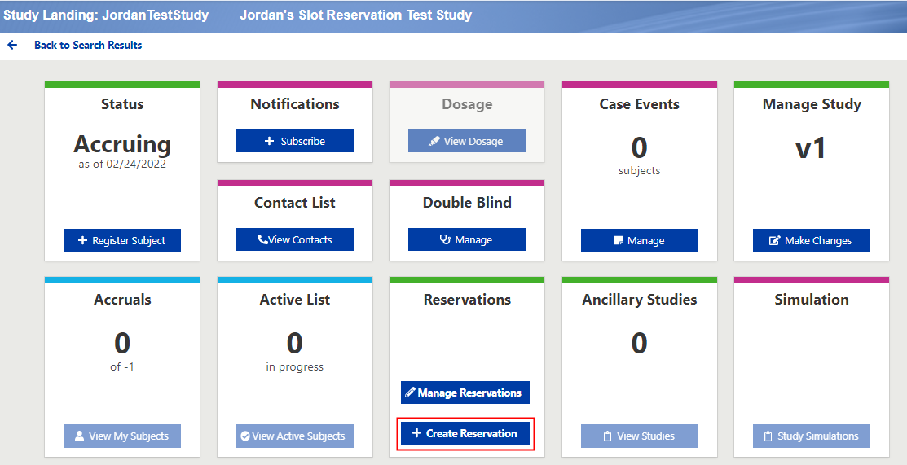

1. Create a Reservation page will be displayed:

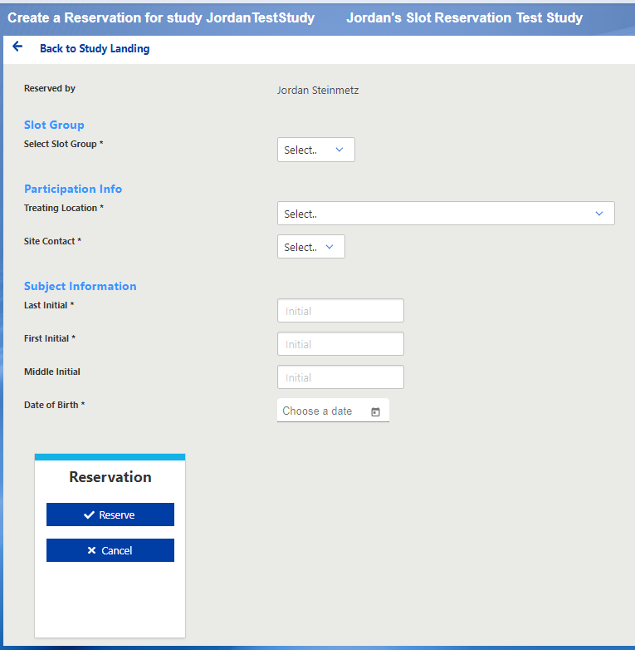

* Reserved by: This will be auto-filled with the name of the person completing the reservation and will be read-only
* Slot Group: If there are multiple cohorts available for slot reservation, use this field to select the appropriate group for the subject.
  + Note: The information in this field will be used to populate the Eligibility Checklist at the time of registration and CANNOT be changed when completing the registration. If the incorrect field is selected on the slot reservation, the reservation must be Removed and a new Reservation should be made using the appropriate slot group. Further instructions included below.
* Participation Info: Enter the participation information for the subject as you would on the Registration. This may include Treating Membership, Treating Location, and Site Contact.
* Subject Information: Enter the subject’s Last Initial, First Initial, Middle Initial (optional), and Date of Birth.
* Click the Reserve button on the Reservation tile at the bottom of the page to complete the Reservation.

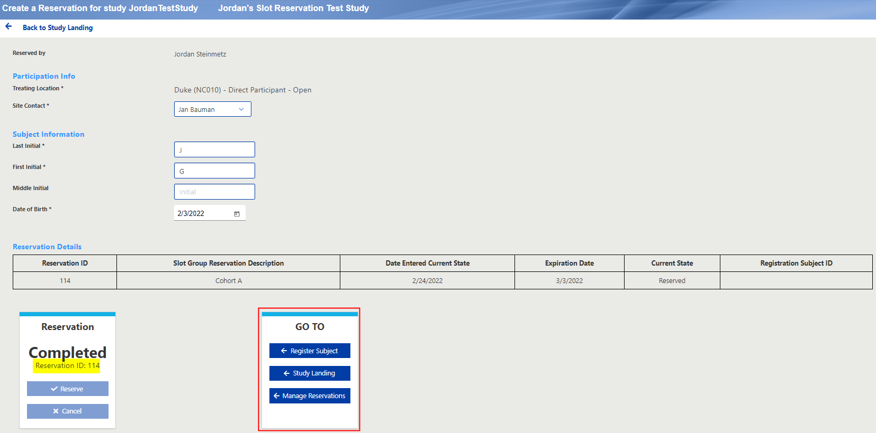

The Reservation status will change to Completed and a Reservation ID will be provided for the reservation.

The Go To tile provides the following options:

1. Register the Subject – Initiate the registration for the subject to complete the eligibility checklist
2. Study Landing – Take the user back to the Study Landing page
3. Manage Reservations – Take the user back to the Study Landing page and open the Manage Reservations preview pane.

## Manage Reservations

Users can manage their existing reservations by clicking the Manage Reservations button on the Reservations tile on the Study Landing page.

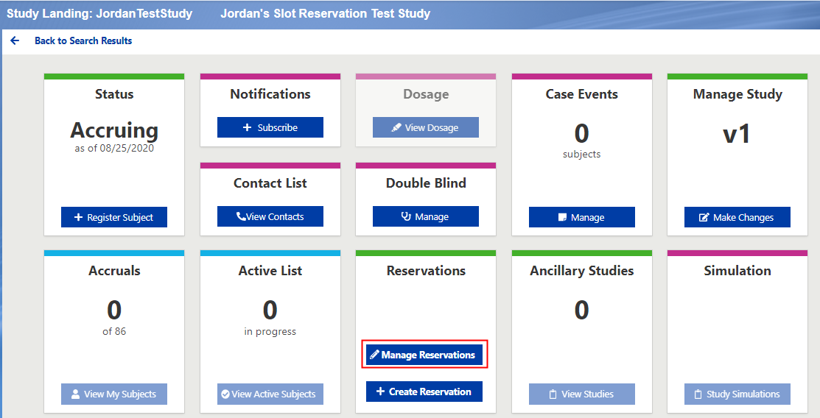

### Study Reservations Preview Pane

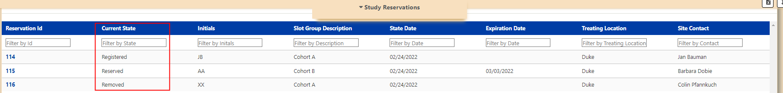Displays all reservations that the user has created for the study

* Reservation ID: Assigned when the reservation was completed. Clicking this link will allow the user to view the full reservation summary and make updates to the reservation.
* Current State: The current status for the reservation:
  + Reserved: Reservation is complete, but the subject has not been registered. This reservation can be updated by the user.
  + Registered: The subject has been registered using the reservation. This reservation can no longer be updated.
  + Registration In Progress: The registration has been initiated for the reservation but has not been completed. The reservation cannot be updated with an in-progress registration. Note: If registrations are left in-progress for more than 7 days without update, the in-progress registration will automatically be removed from the application and the user will need to start over.
  + Removed: The reservation was removed by the user. This reservation can no longer be updated.
  + Expired: The reservation reached the expiration date without being renewed so the reservation is now expired and can no longer be updated.
* Initials: Subject initials entered on the reservation.
* Slot Group Description: Description of the slot group selected on the reservation. This field may be blank if there are no slot group descriptions used on the reservation.
* State Date: Date the Current State was last updated.
* Expiration Date: Date the reservation will expire. This field will be blank for reservations in Registered, Removed, or Expired status as the expiration date is no longer applicable.
* Treating Location: Treating location selected on the reservation.
* Site Contact: Site contact selected on the reservation. Note this may be different than the user that completed the reservation.

### View Reservation Summary

Click the Reservation ID link to view the Reservation Summary and make updates to the reservation.

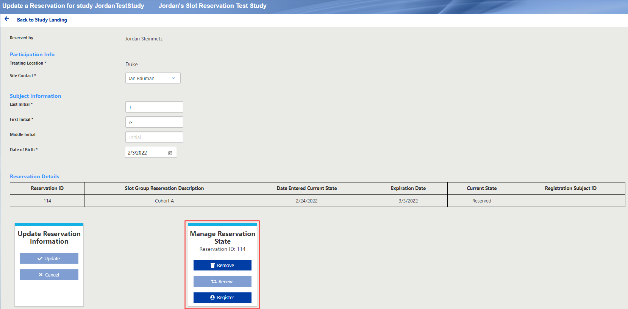

Manage Reservation State

* Remove: If a reservation is in Reserved state, the user can click the Remove button to remove the reservation for the subject.
* Renew: If an email notification has been sent that a reservation will expire in 3 days, the user can renew the reservation by clicking the Renew button. This will only be clickable if the reservation will expire in the following 3 days.
* Register: If a reservation is in Reserved state, the user can click the Register button to initiate the registration for the patient.

### Registering a Patient with a Slot Reservation

The registration can be initiated immediately after completing the Reservation by clicking the Register Subject button on the GO TO tile on the Create Reservation page:

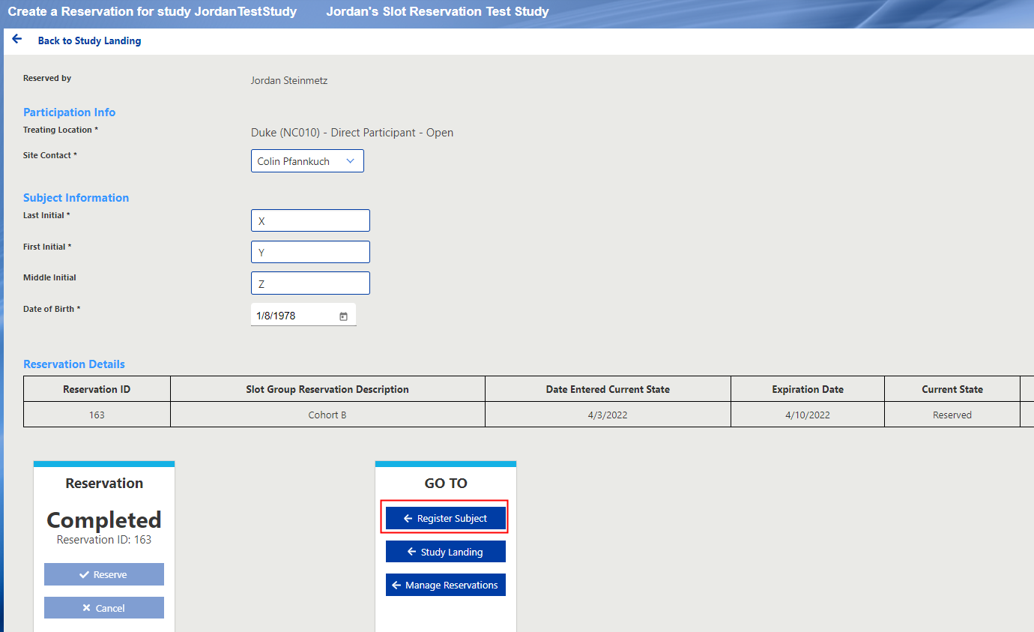

**OR**

The reservation can be initiated via the Update a Reservation page by completing the following steps:

1. Select Manage Reservations button on the Reservation tile

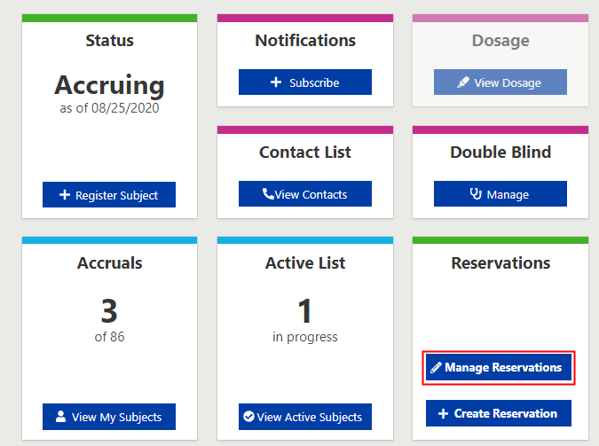

1. Clicking the Reservation ID for the subject in the preview pane summary (the status must be “Reserved”)

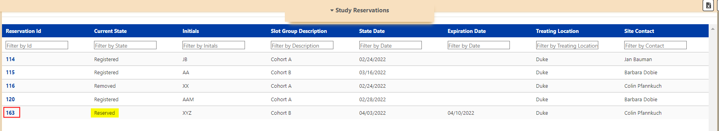

1. Click the Register button on the Manage Reservation State tile:

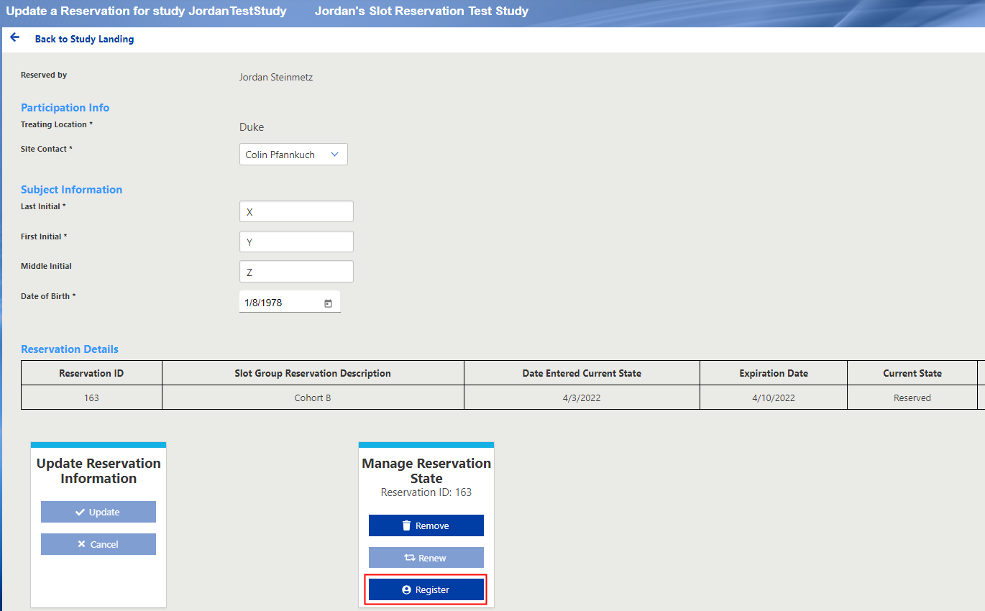

When the Register button is clicked on one of the Reservation summary pages, the registration will be initiated and the user will be brought to the Participation Section. The Treating Location field will be auto-filled with the Treating Location selected on the Reservation but can be updated by the user if necessary. The Subject Info will not be auto-filled.

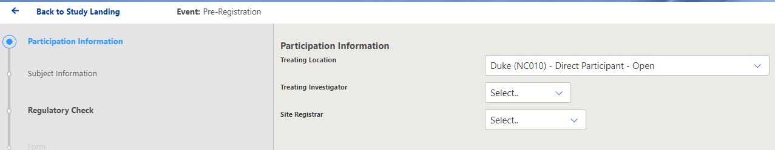

The checklist questions that are associated with the reservation (i.e., Cohort or Dose Level) will be auto filled based on the Slot Group selected on the Reservation. These will be read-only, and the user will not be able to edit these questions on the registration page.

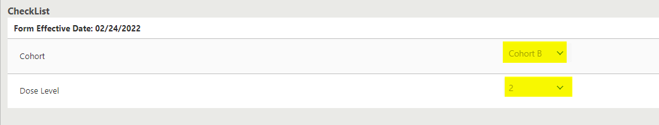

If the incorrect cohort or dose was selected on the Reservation, the user will need to contact the Registration Office ([random01@mayo.edu](mailto:random01@mayo.edu)) to cancel the in-progress registration. The current Reservation will need to be Removed via the Remove button on the Reservation Summary page, and a new Reservation will need to be created with the correct Slot Group selected.

**Note:** The registration must be initiated from the **Slot Reservation summary page** by clicking the Register button. The user cannot use the Register button on the Status tile on the Study Landing page, it must be initiated through the Slot Reservation screen. If they click the Register button on the Study Landing page, they will receive the following message instructing them to use the Reservation tile instead:

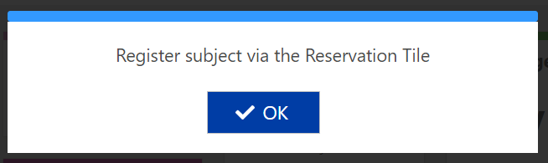

For questions regarding the use of the application or assistance with system issues,   
contact the Research Registration Office at [random01@mayo.edu](mailto:random01@mayo.edu).